AP Human Geography- 9th Grade Full Year Course
2024-2025
R. Wempe
Rachel.wempe@fortbendisd.com

Brief Description of Course
AP Human Geography is an introductory college-level Human Geography course. Students cultivate their understanding of Human Geography through data and geographic analysis as they explore topics like patterns and spatial organization, human impacts and interactions with their environment, and spatial processes and societal changes.

The purpose of the course is to:
1) Introduce students to the systematic study of patterns and processes that have shaped human understanding, use and alteration of the Earth’s surface.
2) Employ spatial concepts and landscape analysis to examine human social organization and its environmental consequences.
3) Analyze spatial relationships at different scales ranging from local to global
4) Utilize geographic methods and tools in other words: Where do People live and Why there?

Course/Academic Expectations:
- As an AP course, naturally, a good amount of work falls on you as the student to read and prepare outside of class.
- Please read each assigned reading in a timely manner. Failure to read the textbook chapters or assigned reading materials will result in your inability to do well on major grades/ reading quizzes.
- Take Cornell or outline notes while reading (Other reading strategies will be discussed as the year progresses)
- Complete all unit vocabulary on time and make sure you study unit vocabulary.
- Turn in all assignments in on time.
- Attend tutorials regularly to get clarification of concepts, study tips, and aid from both your peers and Mrs. Wempe.
- Take advantage of retesting opportunities if needed.
- Cheating/Academic dishonesty is not acceptable. Do not copy the work of other students be it homework, vocabulary, discussions posts, or direct cheating on writing, quizzes, or tests. Evidence of cheating will result in a 0 on the assignment. Repeat offences will result in a discipline referral and notification to national honor societies, club sponsors, and/or coaches.
CLASS DISCUSSION AND READING
- It is critical that everyone participates in class discussions and class activities to get a variety of viewpoints on the subjects that we will be covering. Class discussions are an integral part of this course, and every student is required to respond when questioned and encouraged to give input to class discussions. All reading assignments will be required within each specific unit. You will take quizzes over the readings, and you will need the background knowledge and concepts to be successful in class.
Behavior Expectations
- Follow all district expectations and co-constructed respect agreement.
- Be respectful to everyone. We are a diverse school, and we will be discussing diverse cultures, ideas, opinions, and theories, so it is important to come to class with an open mind and be able to engage in discussions with respect, most importantly when we may not agree.

Cell Phone/headphone Policy:
- Cellphones are expected to be placed in the chart at the front of the room unless otherwise instructed by Mrs. Wempe.
  - If I see your cellphone out without direct instruction to use it a warning will be given. If I see it again, I will take it up, communicate home and return your cell phone at the end of class.
  - If inappropriate cellphone use becomes an issue, I will email home and/or disciplinary action will occur.
  - With being a one-to-one district, there is no need for cell phone use in the classroom.
- Cellphones will stay turned into the cellphone chart when a student is going to the restroom.
- NO earbuds/headphones may be worn unless otherwise instructed by Mrs. Wempe
  - Same warning system will apply to earbuds/headphones as above.
Laptop expectations:
- Students will be expected to bring their fully charged laptops to school everyday.
- Laptops will be used frequently, but possibly not throughout the entire lesson or class period.
- Students are expected to follow the laptop use stoplight. When the arrow is placed on Red, no usage of laptops will occur. Yellow, is at teacher direction and Green is a full academic use. (For example a research day or a digital activity)
- Students are expected to listen to instructions about laptop usage daily.
- Students are expected to only use laptops for academic purposes. Playing games or having other tabs open other than those needed for academic work will not be accepted.
Tutorial Times: (Subject to change)
- Tuesday and Thursday Mornings: 7:00- 7:15 AM
- Tuesday Afterschool: 2:50-3:45
Communication:
- I will communicate with students via Schoology message, their student email, and the remind app.
Textbook: Human Geography: People, Place, and Culture. Fouberg, Murphy, De Blij 11 edition
Online Textbook URL will be given in class.

Unit Information
Unit Name & Tentative Timeframe:
Topic (% goals for MC Exam) | Tentative Test Dates  Subject to change | Textbook Chapters
1. Geography: Its Nature and Perspectives5-10% | MG # 1: TBD  Unit 1: 8/29  Unit 1.5: (Phy. Geo) 9/11 | Fouberg, CH 1
2. Population and Migration 13-17% | Unit 2 Test: 10/9 | Fouberg, CH 2-3
3. Culture 13-17% | Unit 3 Ch 4 & 5: 10/29  Unit 3: Ch 6 & 7: 11/15 | Fouberg, CH 4,6,7
4. Political Organization of Space13-17% | Unit 4: 12/10 | Fouberg, CH 5,8
5. Agriculture and Rural Land Use 13-17% | Unit 5: 2/7 | Fouberg, CH 11
6. Industrialization and Economic Development13-17% | Unit 6: 3/7 | Fouberg, CH 10, 12
7. Cities and Urban Land Use 13-17% | Unit 7: 4/9 | Fouberg, CH 9
AP Exam | 5/6 8 AM
Course work breakdown:
**Each report card will have 6 DGs and 3 MGS

Daily grades can be anything from:
• unit reading quizzes
• Assignments completed in class
• Online assignments in Schoology (TED Talks Etc.)
•Unit Vocabulary
Major Grades can be any of the following:
• Unit Tests
• FRQs (Free Response Questions)
• Project(s)

Make-Up and Late Work
- IT IS THE STUDENT’S RESPONSIBILITY TO GET MAKEUP WORK. If you miss one day and it is an excused absence, you have one day to make up the work. Check Schoology first, then if needed check the folder for the day you were absent in the box on the student desk, make sure you confirm with me that the correct assignment is in that days folder. It is YOUR responsibility to make up work after an absence. I will NOT hunt you down for make-up work. You will also need to check Schoology for any assignments you may have missed.
  - One day for each day of an excused absence will be provided for make-up work.
  - You will need to turn your make-up work directly to me. Do NOT just put it on my desk or you will NOT receive credit.
  - If a test was scheduled before you are absent, then you will be required to take the test the day you return.
- If you were here the day before the announced quiz, test, or assignment due date, you are required to make up the test/quiz or turn in the assignment the day you return, unless you present a doctor’s note indicating an illness. (This includes school sponsored trips and other absences.) You may take the test/quiz or turn in the assignment the day following your return only if you were ill, with an excused absence from the Attendance Office, if not, you will receive a ZERO. If you miss more than one day (excused), you are responsible for arranging a time with me.
- Make-up tests/quizzes must be arranged with me.
- If you are absent on the day a Major Grade Assignment (i.e. Project, Essay) is due, you MUST make arrangements to get the project to class. If you do not, you will receive a late grade.
- School sponsored trips - I will give make-up work before the absence if possible. Again, if you are missing a major test or quiz, you are responsible for making it up the day you return. NO EXCEPTIONS! If a Major Grade project is due on the day of a school sponsored trip, you still must make arrangements to get it to class or it will be a late grade.
- Assignments are due at the BEGINNING of the period on the date specified or it is considered LATE.

Late Grade Policy:
- 1 day late minus 15pts
- 2 days late minus 30 pts
- 3 days late minus 50 pts
- 4 or more days late – NO late work accepted.
Retesting Policy:
- If you score a 69 or below on a Test per district policy, you can retest for up to a maximum of a 75.

Useful Websites/Resources

AP Classroom: College Board
Mr. Sinn – YouTube channel
Crash Course Human Geography – YouTube channel
Population Reference Bureau
United Nations Organization: Human Development Index
Central Intelligence agency

AP Exam study books/recourses: I HIGHLY recommend purchasing a review book early! DO NOT WAIT TIL JANUARY TO START REVIEWING FOR THE EXAM IN MAY!!
** These are suggestions on quality review material.
Resource | Image
AMSCO® Advanced Placement® Human Geography - 2022 |  | iScore5 AP Human Geography App | 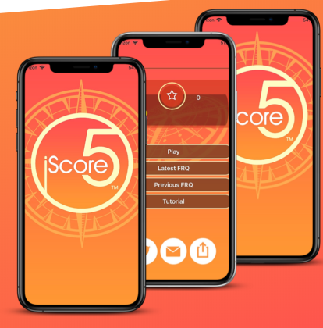
The Princeton Review: AP Human Geography Review | 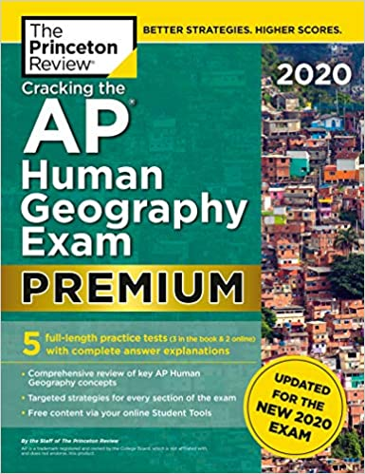
Barron’s AP Review | 

Student and Parent Contract
Please read the syllabus together. Sign and return this page to Mrs. Wempe

I, ___________________________________ have read and agree to the academic, classroom, and behavior
(Student Name)
expectations set forth in this syllabus. I agree to put my best effort forward as I embark on my first AP class.

Student Signature ________________________________ Date:________________ Class period:___________

I, ______________________________________________ have read and agree to the academic, classroom,
(Parent Name)
and behavior expectations set forth in this syllabus for my child. I have updated Skyward family access to make sure my email and phone numbers are up to date.

Parent Signature _________________________________ Date: ________________

